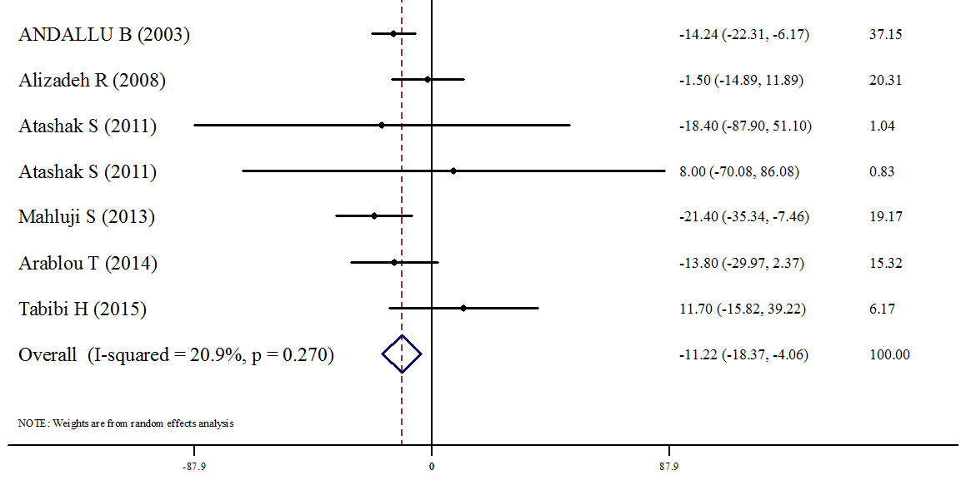
Figure 2 : Forest plots depicting the effect of Ginger supplement on LDL-c

