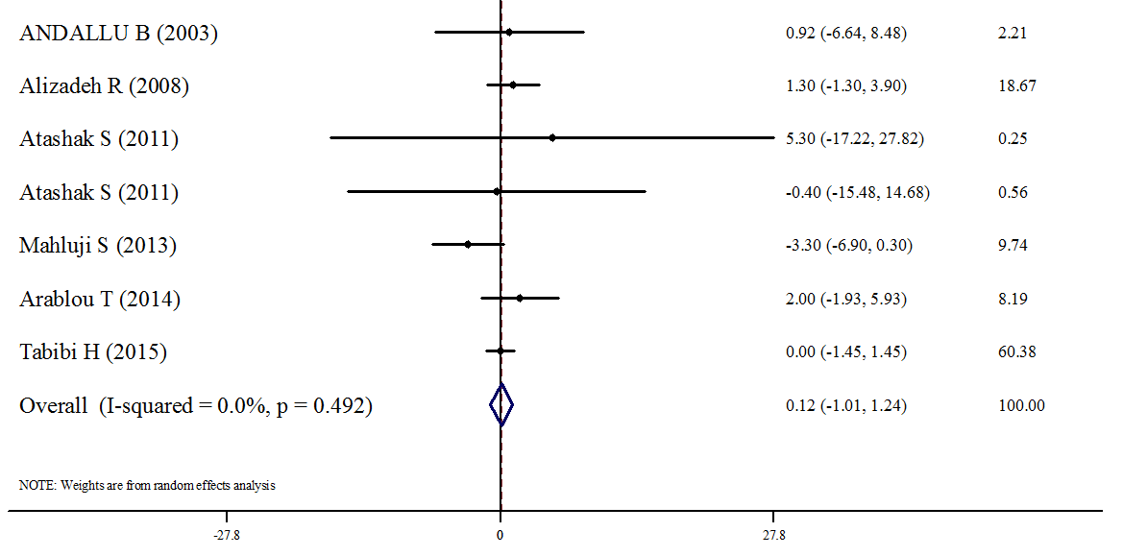
Figure 3 : Forest plots depicting the effect of Ginger supplement on HDL-c

