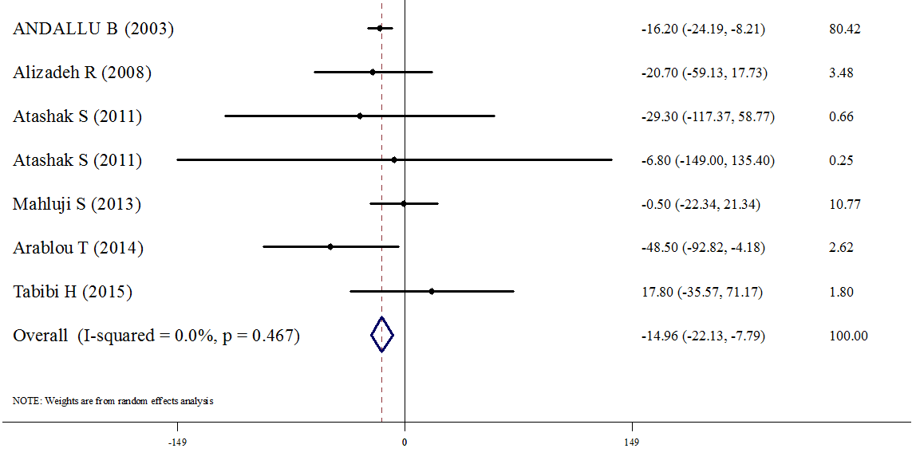
Figure 4: Forest plots depicting the effect of Ginger supplement on TG

