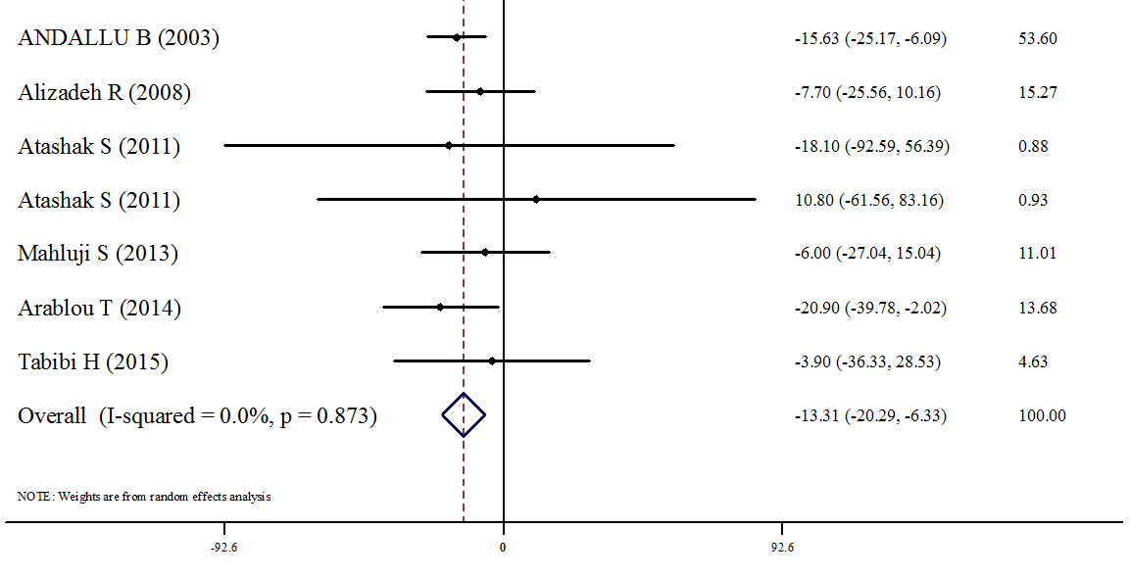
Study (year) WMD (95%CI) Weight%

Figure 5: Forest plots depicting the effect of Ginger supplement on TC

