Dear Dr.
Editor in chief of Journal herbal medicince

All authors have read and approved the final draft of the manuscript entitled Investigating the Effect of Hydroalcoholic Extract of Sesame and Ziziphora clinopodioides phora Clinopodioides in Treatment of Testicle Damages Resulted from Streptozotocin-Induced Diabetes in Vistar Rats

”. The mentioned manuscript is neither accepted for publication nor published in another journal in full or part (except in abstract form). I hereby assign the copyright of the enclosed manuscript to Journal herbal medicince
List of authors
Row | Full Name of Authors | Affiliation (Academic degree, Department, university) | Signature
1 | Amir hossien toozandehjani (msc) | Department of medical radiation engineering, Islamic Azad University, Shahroud, Iran  Orcid id=0000-0002-1311-0319 | 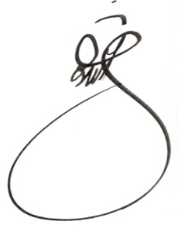
2 | Sahar Molzemi(msc) | School of Medical Sciences, Shahrood Branch, Islamic Azad University,Shahrood, Iran  Orcid id=0000-0003-3069-5926
3 | Nahid bolbol haghighi(msc) | Department of Midwifery, school of Nursing and Midwifery,Shahroud University of Medical Sciences, Shahroud, Iran  Orcid id=0000-0002-9639-7422 | 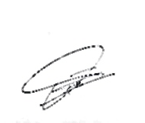
4 | Hamid Mohammad Sadeghi(M.Sc.) | Physiology Department, Faculty of Medicine, Shahid Sadoughi University of Medical Sciences, Yazd, Iranic of Iran Army, Tehran, Iran  Orcid id= 0000-0003-3167-4780 | 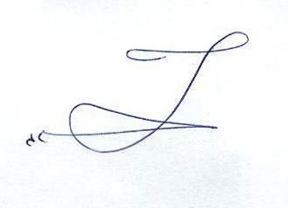
5

