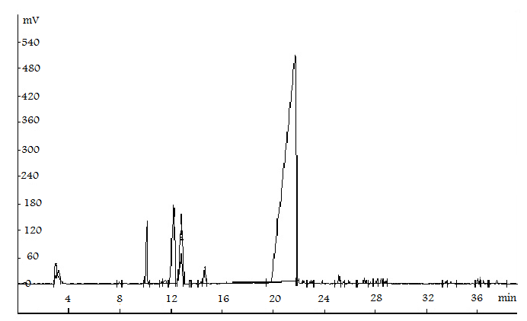Figure 1 Chromatogram (GC) of the essential oil of the Echinophora Cinerea

